Introduction to Section 2:

Symbiosis

In nature, we often witness two or more organisms coexisting harmoniously, engaging in mutually beneficial physiological interactions. Classic examples include clownfish seeking refuge from predators within sea anemones in exchange for providing protection and nutrient-rich excrement, or monarch butterflies pollinating flowers. Yet, we need not look beyond ourselves to recognize symbiotic relationships. In fact, there are more non-human cells residing on and within the human body than actual human cells, thanks to the diverse bacteria, archaea, fungi, and viruses that form our microbiome. This microbiome is now recognized for performing a variety of essential functions, from aiding digestion and nutrient production to protecting against pathogens, and even influencing our mental well-being.
Symbiosis refers to the physiological interaction between two or more unlike organisms. While some microbiologists may not consider the relationship between clownfish and anemones a true symbiosis—since it doesn’t involve direct physiological interaction—most contemporary definitions of symbiosis, especially in animal biology, include persistent biological interactions between different species, such as those between clownfish and sea anemones. There are three primary types of symbiotic relationships: mutualism, commensalism, and parasitism. A common misconception is that symbiosis only refers to beneficial interactions (mutualisms), where both organisms benefit from the relationship. In reality, symbiosis encompasses a broader spectrum, including parasitic and commensal interactions, where the benefits and costs to each organism can vary depending on environmental circumstances and the life stages of the symbionts.
Symbiotic relationships typically evolve over generations, with each organism influencing the other through selective pressures. These relationships have been developing for billions of years and continue to evolve. In this section, we will focus on mutualisms between the Cannabis plant and members of the Kingdom Fungi.
Microbes are ubiquitous across all ecosystems and interact with every organism, sometimes causing disease while at other times promoting health. These microbes are found in remarkable numbers in the air and soil around us. For instance, soil scientists have found that a single gram of soil contains more organisms than the entire human population on Earth—about 10 billion bacterial cells per gram, compared to a global population of 8.2 billion people in 2024 (Raynaud & Nunan, 2014). Microbes play diverse roles in ecosystems, and the microbiomes of complex organisms are essential for maintaining homeostasis. As such, soil organisms interact both directly and indirectly with Cannabis plants.
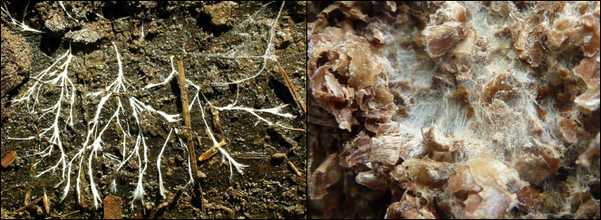
Figure 1. Fungal mycelium growing in soil, digesting organic matter and releasing bioavailable nutrients.

Fungi that directly interact with Cannabis in the soil include mycorrhizal fungi such as Funneliformis and Rhizophagusspecies. Soil saprophytic fungi, ranging from decomposing mushrooms to less-visible molds, play crucial roles in nutrient cycling, water retention, and maintaining the ecological health of the soil microbiome (see Figure 7.2). On the other hand, fungal pathogens can be harmful, often preying on weak plants or certain individuals within a population. In some cases, fungal pathogens can devastate entire crop fields or cause significant economic losses.
Entomopathogenic fungi, which metabolize insects and arthropods as food, provide another example of symbiotic interactions. These fungi consume their hosts and then produce spores to infect new insect or arthropod hosts. Some species may serve as biological control agents, naturally combating pests like aphids, thrips, and whiteflies in agricultural settings, including Cannabis crops. While some entomopathogenic fungi may also act as plant endophytes, promoting plant growth, they can also cause damage, such as the production of fungal sclerotia replacing grain, as seen in Ergot (Claviceps sp.) and Corn Smut (Ustilago maydis).
All of these examples represent symbiotic relationships where organisms of different species interact physiologically, impacting each other's growth and fitness. The primary goal of The Mycology of Cannabis is to explore the various ways Cannabis interacts with fungi—from mutualistic to commensal and parasitic relationships. This understanding offers valuable insights for farmers, enabling them to leverage these interactions to their advantage. Fungal symbioses with Cannabis play pivotal roles in cultivation and processing, affecting every aspect of the plant’s life cycle.
Chapter 7
Mycorrhizae
One of the most well-studied examples of mutualistic symbiosis, where both partners benefit, is the relationship between land plants and mycorrhizal fungi. Researchers hypothesize that these fungi, which reside on or in the roots of plants to help them acquire water and nutrients, played a crucial role in enabling plants to transition from aquatic environments to land (Bonfante and Genre 2008). This relationship has been evolving for hundreds of millions of years, which is reflected in the fact that the majority of land plants form some sort of intimate partnership with mycorrhizal fungi (Chenchouni et al. 2020). In some cases, individual plant roots can form associations with more than one species of mycorrhizal fungus (Blaschke 1991).
The term mycorrhiza literally means "fungus-root," which is an ideal name for this coevolutionary relationship. Given that this partnership has been developing and evolving for such a long period, both partners—plants and fungi—are highly specialized in their roles. But what do each organism gain from this relationship?
Fungi are heterotrophs, meaning they must acquire carbon from their environment. Mycorrhizal fungi achieve this by siphoning off carbon that has been fixed from atmospheric CO2 by their plant hosts. Plants, through photosynthesis, are able to synthesize sugars from sunlight, CO2, and water. Plants produce more sugar than is necessary for their own growth, and the excess sugar is transported down to the roots, where it is released into the surrounding soil in the form of root exudates (Aulkah et al. 2001). One function of these root exudates is to attract beneficial microorganisms that assist the plant in various ways (Herz et al. 2018).
Among the microbes attracted to this sugary extracellular matrix are mycorrhizal fungi. In fact, spores of some mycorrhizal fungi even require the presence of these root exudates to germinate (Vierheilig et al. 2003). Upon detecting certain compounds in the exudates, the spores swell and a hypha called a germ tube begins to emerge from the spore. The hyphae then grow towards the root, and depending on the species of fungus, they may penetrate the plant’s cell walls (as in the case of endomycorrhizae infecting Cannabis) or form a sheath around the root (as seen in ectomycorrhizae) (Fig. 7.1). A well-known example of an ectomycorrhizal fungus is Amanita muscaria, commonly known as the fly agaric.
Once the plant and fungus establish this connection, the fungus begins to acquire water and difficult-to-obtain nutrients—such as phosphorus—from the surrounding environment. The highly branched and thin fungal hyphae extend the root surface area, allowing the plant to access areas of the soil that it would not otherwise be able to penetrate. In this way, the fungus acts as an extension of the plant's root system, greatly enhancing its ability to acquire resources.
Mycorrhizal fungi also release organic acids, enzymes, and siderophores into the soil, which help break down complex molecules into simpler forms that can be utilized by both the fungus and the plant. This process enables fungi to acquire minerals from the soil at rates that plants themselves cannot achieve on their own. In return for these vital nutrients, the plant provides the fungus with sugars produced via photosynthesis. This exchange of nutrients and carbohydrates forms the core of the mutualistic relationship. Additionally, there may be a complex transfer of nutrients and even signaling molecules between plants connected through the same mycorrhizal mycelium network.
In nature, we observe various types of mycorrhizal relationships. While new subclasses are continually being discovered, there are three main types of mycorrhizal associations (Brundrett 2009). For the purposes of this discussion, we will focus on endomycorrhizae and ectomycorrhizae, with a particular emphasis on endomycorrhizae, as they are the only group known to form direct partnerships with Cannabis.
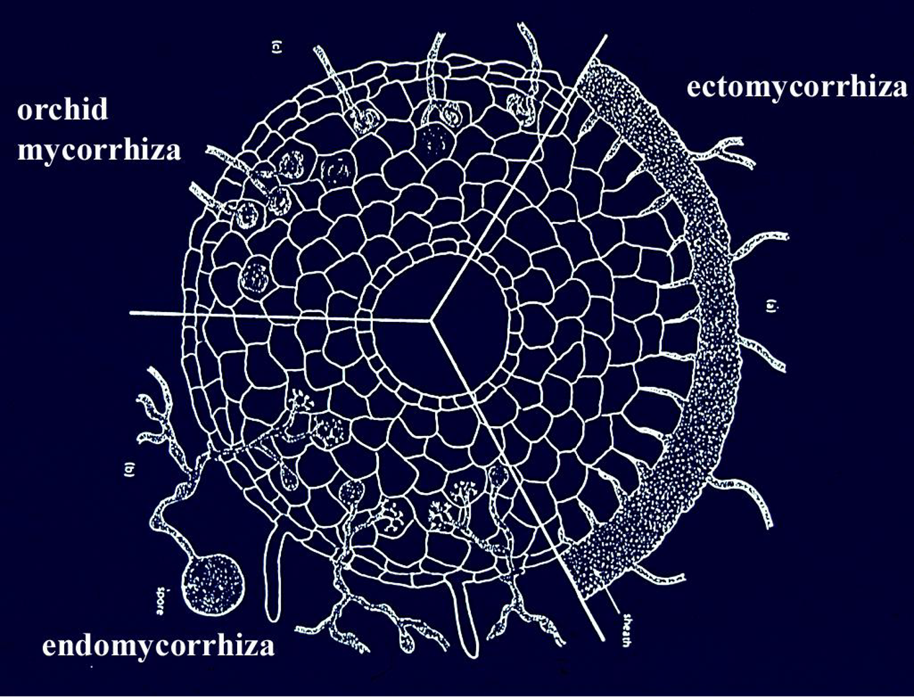
Figure 7.1 Cross section diagram of a plant root infected with different types of mycorrhizal fungi. (A) Ectomycorrhizal, (B) Endomycorrhizal, (C) Orchid mycorrhizae. From Tom Volk

Table 1. Common species of Endomycorrhizae vs Ectomycorrhizae
Endomycorrhizae | Ectomycorrhizae
Funneliformis  Glomus  Rhizophagus  Gigaspora  Planticonsortium | Tuber (Truffle)  Amanita  Laccaria  Boletus  Morchella
Plant associates: Cannabis, most vegetable and herbaceous plants, many grasses | Plant associates: Hardwood and softwood trees, many woody plants

Mycorrhizae Taxonomy
As with many other groups of fungi, the taxonomy of mycorrhizal fungi remains in a state of flux. Species are regularly being renamed or reclassified as our understanding of the fungal kingdom deepens and as our identification techniques improve. Despite this, there are broad taxonomic guidelines that are generally followed.

Endomycorrhizae
Historically, endomycorrhizae were classified within their own phylum, Glomeromycota. However, recent phylogenetic analysis has reclassified them within the subphylum Glomeromycotina under the phylum Mucormycota. Fungi in this subphylum lack septa and are coenocytic, meaning their hyphal cells are multinucleate without divisions between them. Additionally, Glomeromycotina fungi are obligate symbionts of plants. Cultivating these fungi can be challenging because they cannot be cultured in vitro without a host; they must be grown in association with an appropriate plant symbiont. Their spores are produced directly from the mycorrhizal hyphae and are dispersed through the soil, primarily by insects, arthropods, and small mammals. Collecting spores for inoculum production is more difficult than collecting spores from mushrooms, as they are only available after the host plant has grown and died.

Ectomycorrhizal Fungi (ECM)
Ectomycorrhizal (ECM) fungi are typically found in the phyla Basidiomycota and Ascomycota. They generally reproduce through sexual spores, and many ECM fungi produce recognizable mushrooms or underground fruiting bodies, such as truffles. Most deciduous and coniferous trees form associations with ECM fungi, which are found across all types of forests but are particularly diverse and abundant in old-growth forests where the soil has never been disturbed. Other mycorrhizal types, such as Orchid mycorrhizae (Basidiomycota), Ericoid mycorrhizae (Ascomycota), and Monotropoid mycorrhizae (Basidiomycota), also belong to these two phyla. However, there is no evidence that any of these higher fungi form mycorrhizal infections with Cannabis plants.
Table 7.2 Different mycorrhizal groupings and associated characteristics. Character occurrence among grouping indicated by “+,” absence by “-”.
Characters | AM | Ecto | Ecto/endo | Ericoid | Arbutoid | Monotropoid | Orchid
septa | - | + | + | + | + | + | +
Inracellular host colonization | + | - | + | + | + | + | +
Fungal sheath | - | + | +/- | - | +/- | + | -
Hartig Net | - | + | + | - | + | + | -
Fungal taxa | Mucoro- | Mucoro-  Basidio-  Asco- | Basidio | Asco-  Mucoro- | Basidio- | Basidio- | Basidio-
Plant host taxa | Occur across all vascular and non-vascular plants | Gymno- and Angiosperms | Gymno- and Angiosperms | Ericales  Bryophytes | Ericales | Monotropoid | Orchidaceae

Endomycorrhizae
Endomycorrhizae are mutualistic fungi that form associations with many vascular plants. These fungi are considered "generalists" because they are not host-specific and can infect a wide variety of plant species. It is estimated that over 80% of all species of land plants form associations with endomycorrhizae (Schwarzott et al., 2001). Endomycorrhizal fungi are particularly significant in agriculture, as they are commonly associated with short-lived, annual crops like corn, wheat, and many vegetables. These fungi help plants acquire vital nutrients, particularly phosphorus, in exchange for carbon sourced from the plant's photosynthesis.

Classification Challenges
Classifying endomycorrhizal fungi has remained difficult because they cannot be cultured in vitro without a host, making it challenging to study them outside of their natural symbiotic relationships. For many years, it was believed that all endomycorrhizal fungi belonged to the subphylum Glomeromycotina, formerly classified as Glomeromycota (Bruns et al., 2017). Within Glomeromycotina, there are three classes, five orders, 14 families, 29 genera, and approximately 230 species (Oehl et al., 2010). Fungi in this subphylum are often called arbuscular mycorrhizal fungi (AMF) or vesicular arbuscular mycorrhizal fungi (VAM), referring to the tree-like branching structures called arbuscules that form inside the plant root cells (Fig. 7.2).

Emerging Evidence: Mycoromycotina and MFRE
Recent studies have suggested that the sister subphylum to Glomeromycotina, called Mycoromycotina, may also form mycorrhizal relationships with a wide variety of plants (Bonfante and Venice, 2020; Howard et al., 2022). Fungi in Mycoromycotina may form structures called arbuscules, which have historically been misidentified as belonging to Glomeromycotina. The hyphae of Mucoromycotina endophytes, also known as Mucoromycotina Fine Root Endophytes (MFRE), have a distinct characteristic: their hyphae are smaller in diameter (<2 micrometers).
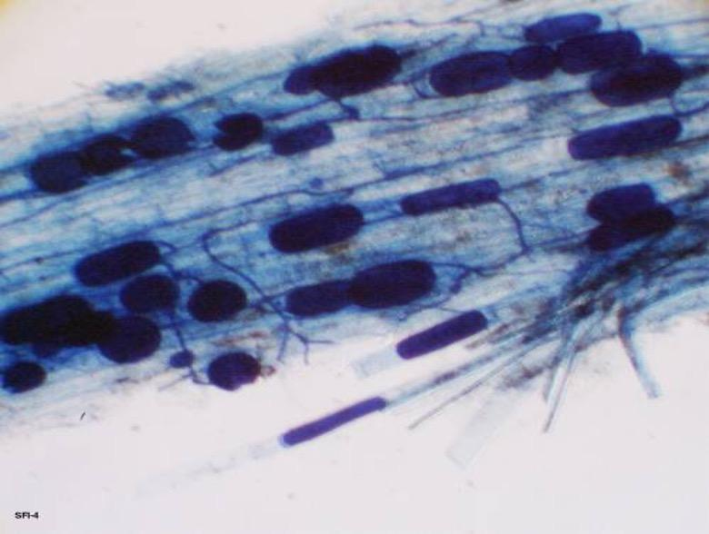
Fig. 7.2 Plant root infected with endomycorrhizae that are producing vesicles, spores, and hyphae penetrating the root and growing in between cortical cells.
There is evidence that MFRE and Glomeromycotina AMF form complementary associations with the same plants, providing different nutritional exchanges. For instance, MFRE are believed to mainly contribute nitrogen to their host plants, whereas Glomeromycotina AMF primarily scavenge phosphorus, both in exchange for carbon from the plant's photosynthesis (Field et al., 2019).

Key Characteristics of Endomycorrhizal Fungi
All Glomeromycotina AMF form arbuscular mycorrhizal associations, and they share certain traits and characteristics:
- Coenocytic hyphae (aseptate, multinucleate)
- Obligate symbiosis (require a host organism to complete their life cycle)
- Spore reproduction (they reproduce by producing spores that are dispersed in the soil)
Mucoromycotina Fine Root Endophytes (MFRE), while similar in some respects (coenocytic hyphae and spore reproduction), are not obligate symbionts. MFRE are facultatively saprophytic, meaning they can survive, grow, and reproduce without a living plant host, unlike AMF, which absolutely require a plant host to complete their life cycle (Field et al., 2015). This saprophytic capability of MFRE opens up opportunities for working with this grouping of fungi in ways that are not possible with obligate symbionts like Glomeromycotina AMF.
Table 3. Hierarchical classification of Arbuscular Mycorrhizal Fungi (Walker et al 2018)
Kingdom | Fungi
Phylum | Mucoromycota | Mucoromycota
Subphylum | Glomeromycotina | Mucoromycotina
Class | Archaeosporomycetes, Glomeromycetes, and Paraglomeromycetes | Mucoromycetes
Order | Archaeosporales, Diversisporales, Gigasporales, Glomerales and Paraglomerales | Endogonales, Mucorales  (Incertae sedis)
Family | Glomeraceae, Gigasporaceae, etc. | Endogonaceae  (Incertae sedis)
Genus | Glomus, Gigaspora, Funneliformis, Rhizophagus, ect. | Planticonsortium
Species | Funneliformis mosseae, Rhizophagus intraradices, ect. | Planticonsortium tenue (Synonym, Glomus tenue)

The mechanism by which a spore finds a root to infect is complex and not fully understood, though scientists know that both the spore and the plant can grow toward each other despite being sessile organisms. Environmental factors such as pH, temperature, microbial community, and nutrient availability are thought to influence spore germination (Giovannetti et al., 2010).
Plants, being sessile, attract beneficial microorganisms by excreting chemicals, mainly carbohydrates and pheromones, from their roots. This area, known as the rhizosphere, fosters a diverse microbial community. Research indicates that many sugars produced by plants through photosynthesis are directed to the roots and released into the rhizosphere to attract microbes (Canarini et al., 2019). By secreting sugars and other compounds, the plant signals compatible organisms like endomycorrhizal fungi to grow toward the root, where the fungal hyphae penetrate the root’s cell wall.
Once the fungus nears the root epidermis, it secretes mucilage and other sticky substances to adhere to the plant (Balestrini and Bonfante, 2014). The fungus senses specific exudates, such as lactones, and its hyphal tip swells, forming a specialized structure called an appressorium or hyphopodium (Genre et al., 2005). This structure assists in establishing the symbiosis and breaks down after penetration. Typically, the fungus enters through a single-celled root hair rather than the root meristem (Bonfante and Genre, 2008). Upon entry, the hyphae travel through the apoplastic pathway to the root cortex, where they form arbuscules to exchange resources with the plant (Genre et al., 2005). These structures increase the surface area for nutrient exchange between the fungus and plant cells.
Endomycorrhizal fungi can also produce vesicles (Fig. 7.2), which are lipid-rich structures thought to serve as nutrient storage during harsh conditions (Müller et al., 2017). The fungal mycelium extends into the soil, secreting acids to solubilize minerals, which it then absorbs and passes onto the host plant. Fungi like AMF can also release glomalin, a compound that deposits carbon into the soil, improving soil structure and contributing to carbon sequestration (Zhu and Miller, 2008).
In addition to enhancing nutrient and moisture uptake, endomycorrhizal fungi can help protect plants like Cannabis from soil-borne pathogens, such as Fusarium and Verticillium species (Benhamou et al., 1994; Liu, 1995). The fungi compete with pathogens for resources, reducing their impact on plant growth and enhancing plant health. They may also trigger plant defense pathways and alter the rhizosphere or root structures (Singh and Giri, 2017).
Another potential benefit for Cannabis growers is the fungi's ability to translocate heavy metals. Research shows that Funneliformis mosseae inoculated plants grown in metal-contaminated soil translocate metals to their shoots, aiding in phytoremediation (Citterio et al., 2005). However, craft growers should be cautious about using AMF in soils with heavy metal contamination, as it may lead to heavy metal accumulation in plant tissues.
Mycorrhizal fungi are also part of a larger mycorrhizal network (MN) that connects plants through their hyphal systems. This network allows plants to send distress signals and share or steal resources from neighbors (Gorzelak et al., 2015). This could benefit growers using raised beds, where multiple plants share a container and thus interact through the mycorrhizal network (Higgins and Hussey, 2019).
However, these networks can be fragile and disturbed by soil tilling. Although fungal spores remain after tilling, it takes time for the fungi to re-establish associations with plant roots (Kabir, 2005). This is one reason some farmers opt for no-till farming, which preserves the mycorrhizal community.

Mycorrhizae in the garden
There are many commercially available mycorrhizae products on the market today. Go into any nursery or super store and there will likely be numerous products that contain various mycorrhizal species. When shopping for the Cannabis plant, it is important to be selecting products that contain endomycorrhizal fungi. The timing of application is also important to increase the effectiveness of the various products.
Many of the products are sold in a dry powder or granular form. We like to use these products whenever transplanting plants. Take some of the dry powder (we like to put the powder in an old seasoning bottle for easy application) and pour directly onto the exposed roots. We will then rub the powder along the roots to ensure even application and that spores will come in direct contact with the roots. When treating large quantities of plants, you may dip and agitate the rootball in a bowl of powdered inocula. These dry products contain the spores of mycorrhizae fungi and/or “propagules.” The propagules are typically root fragments that have previously been colonized by a mycorrhizal fungus which will eventually grow out and colonize the new root zone.
Other products are sold as a wettable powder or as a liquid solution that is meant to be watered in as a soil drench, thus getting the mycorrhizal spores/propagules close to the rhizosphere, or used as a liquid root dip. The liquid products can also be put into a spray bottle and sprayed directly onto roots at time of transplant. Do not spray on any part of the plant besides the roots. The products contain mycorrhizal propagules that will begin to grow and search for roots once watered into the medium. As such, these products can be used to inoculate plants at any time in the growing phase. However, in order to gain the most benefits from mycorrhizae, it is important to inoculate roots when they are young, developing lots of root hairs and branching, and before the plant’s rhizosphere becomes dominated by non-mycorrhizal soil microbes (including potential pathogens).

Important Notes:
- In high phosphorus environments, mycorrhizal associations may not develop and in some instances, the fungus may actually negatively impact the growth of the plant (Ortas 2003). Cannabis growers must be conscious of this when adding bloom boosters or high phosphorus fertilizers if also attempting to utilize mycorrhizae.
- Mycorrhizal fungi may contribute to heavy metal accumulation in the aerial parts of Cannabis if the soil is contaminated.
- Mycorrhizal products may harbor viruses and bacteria. There is currently no viral indexing of mycorrhizal products sold on the market.

By incorporating mycorrhizal fungi into your indoor Cannabis garden, you can increase the tolerance of your plants to abiotic stresses, such as heat and drought, and biotic stressors, including molds and insects (Trouvelot et al. 2015). Plants with mycorrhizal partners are also better at scavenging nutrients and minerals, often leading to larger, more robust, healthier plants.
In an outdoor Cannabis garden it becomes even more important to inoculate plants with mycorrhizal fungi. Depending on the location and past uses of the farm, there may be spores in the soil, yet inoculating plants can improve the infection rate of plants. Outdoor soils typically can have a more diverse microbial community and are often subjected to more stress. Outdoor soil consisting primarily of sand, silt, and clay, also behaves differently (chemically, physically, and biologically) than indoor potting media which is typically peat or coco coir based. Depending on the soil type, many ionic nutrients may be bound to soil particles and mycorrhizal fungi are particularly good at freeing up these elements and making them plant available.
There are very few studies that have documented the benefits of using mycorrhizae in hydroponic systems but there is research being conducted in this area (Ojala and Jarrell 1980, Aini et al. 2019, Caser et al. 2019, Nurbaity et al 2019). Many have reported anecdotal evidence that incorporating these fungi in these systems has benefits, but solid evidence and hard data is somewhat lacking in regards to Cannabis production in hydroponic systems.

Ectomycorrhizae
Ectomycorrhizae (ECM) are the second most common type of mycorrhizal association, though they do not form relationships with Cannabis plants. ECM fungi are typically found in many tree and shrub species and are known for producing large mushrooms, some of which are edible and delicious (like truffles and morels), while others can be toxic or hallucinogenic.
Unlike endomycorrhizal fungi, which all belong to the same phylum, ECM fungi are spread across several phyla, including Basidiomycota, Ascomycota, and, less frequently, Mucoromycota. This indicates that mycorrhizal relationships in ECM fungi have evolved independently multiple times. ECM communities are commonly found in old-growth forests, where they form associations with many tree species. While some ECM species are host-specific, others are generalists and can form relationships with various plant species, sometimes simultaneously. Additionally, multiple fungal species may coexist on different parts of the same plant root.
ECM fungi typically infect plants by developing a fungal sheath (or fungal mantle) around the outside of the root. Some hyphae extend into the soil, while others enter the root but do not penetrate the plant’s cell walls—unlike AMF or MFREfungi, which penetrate the root cells. Instead, ECM fungi form a network of hyphae in the Hartig Net, an intercellular space between plant root cells, which facilitates nutrient exchange similar to the function of arbuscules in endomycorrhizae.
Another key distinction is that ECM fungi generally have septate hyphae, meaning they have cross-walls, unlike the coenocytic (aseptate) hyphae found in AMF and MFRE. The type of septa depends on whether the ECM fungi belong to Basidiomycota (with dolipore septa and clamp connections) or Ascomycota (with simple porate septa).
Like other mycorrhizal relationships, ECM fungi and their host plants both benefit. The plant shares carbohydrates from photosynthesis, while the fungi provide additional water and nutrients. There is also evidence suggesting that ECM fungi can help protect trees from pathogens and communicate with nearby trees through the mycorrhizal network (Gorzelak et al., 2015).
Although ECM fungi are more commonly associated with perennial woody plants and trees, they are not typically found in vegetable or Cannabis gardens. Some companies market products for Cannabis that contain ECM spores, usually of species that associate with woody trees. This is often seen as “label dressing”, where companies attempt to enhance the product's appeal without offering any real benefit, as ECM fungi do not form mycorrhizal associations with Cannabisroots. While ECM fungi play important roles in nutrient cycling in forest ecosystems, they serve little purpose in Cannabis or vegetable gardens, though they may act as saprophytes in these environments.
A Note of Caution
Although the plant-mycorrhizae relationship can be beneficial for both partners, recent research has shown that there could be some potentially damaging consequences of mycorrhizal infection. Miozzi et al. reviewed the current research in 2019 and revealed that in certain situations plants that have mycorrhizal partners may have increased susceptibility to pathogenic viruses, a term they coin “mycorrhiza-induced susceptibility” (MIS). Scientists are still working to understand this phenomenon better and its potential implications. There may even be direct biological risk to endophyte introductions if they carry pathogens themselves (see Chapter 11 on the emerging threat of fungi as hosts and vectors of plant viruses and viroids).
Another study by Garrido et al. showed that increasing the rate of inoculums with Glomus species actually decreased the plants ability to defend itself to herbivory (Garrido et al. 2010). Again the mechanisms here are not yet fully understood but the point here is that under certain circumstances mycorrhizal inoculation may not be the best use of fertilizer dollars. The key is to experiment, observe, and measure the plant response when debating adding any new product into your grow or farm.
Rhizophagy Cycle
The Rhizophagy cycle is a different form of mutualistic symbiosis between plant roots and certain microbes, such as bacteria and yeasts. The term rhizophagy means "root-eating," and it aptly describes the process in which plant roots consume free-living microorganisms, extract nutrients from them, and then expel the microbes back into the soil. This challenges the traditional view of plants as purely autotrophic organisms, as the process incorporates a heterotrophic mechanism of nutrient acquisition (Paungfoo-Lonhienne et al., 2010).
The cycle begins when certain bacteria or yeasts from the rhizosphere (the zone surrounding plant roots) are assimilated into the plant's root cells. Plant-produced reactive oxygen species (ROS) degrade the microbe's cell wall (Fig. 7.4), leaving behind the plasma membrane. This breakdown allows the plant to absorb nutrients that leak from the microbe. Once these nutrients are extracted, the wall-less microorganisms travel towards the root hair cells, causing the root hairs to elongate. This elongation creates an exit route for the microbes to leave the plant, return to the soil, and rebuild their cell walls as they gather more resources to continue the cycle.
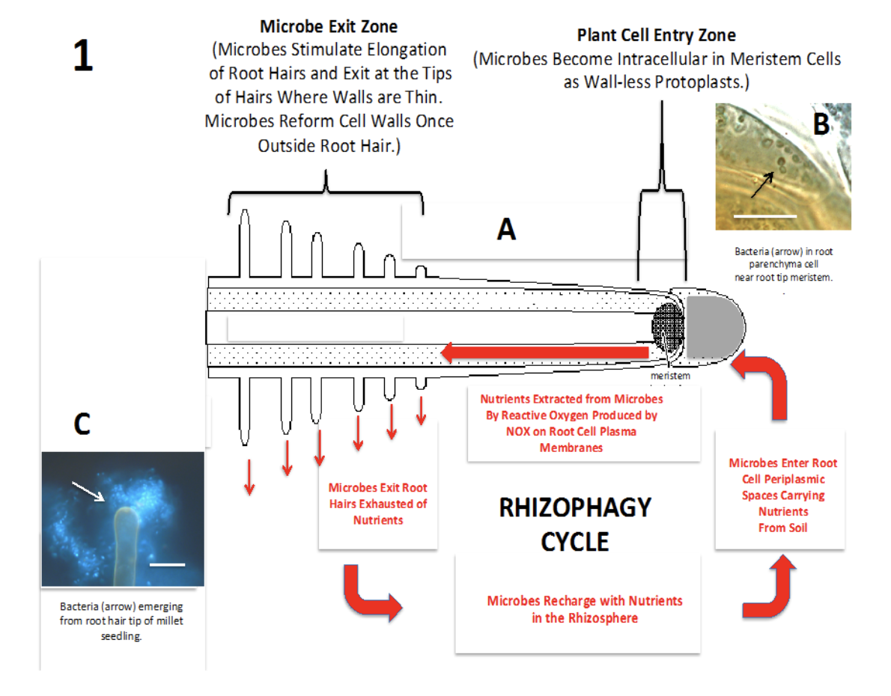
A
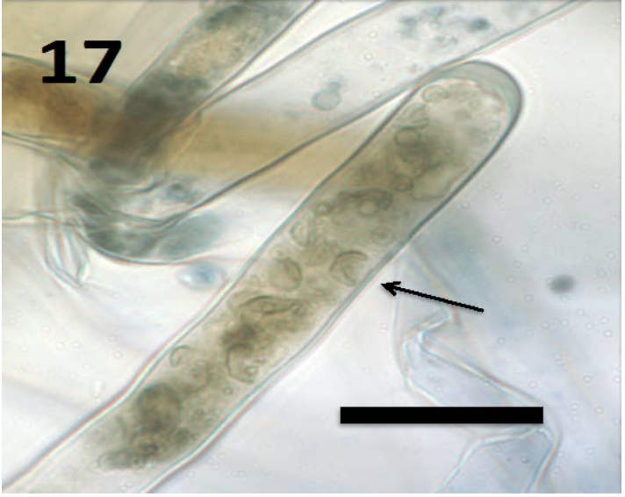
B
Fig 7.3 A) Diagram of rhizophagy cycle in plant root. B) 100x magnification yeast cell inside root hair White et al. 2018
Though it remains unclear how much of a plant's overall nutrient needs are met through rhizophagy, this cycle fundamentally shifts our understanding of plant nutrition. While researchers are still uncertain about whether only specific species of bacteria and fungi can engage in rhizophagy, it appears that most microbes colonizing plant roots are capable of participating in this process (White et al., 2018).
In summary:
- Mycorrhizae is category of a mutualistic relationship between plants and fungi where both partners are benefiting
- Fungi help plants scavenge for resources and in return the plant feeds the fungi with sugars made by the plant during photosynthesis
- Only endomycorrhizae infect Cannabis roots

Chapter 8
Endophytes

Introduction

Since the existence of endophytes was first noted by Henry Anton De Barry over 150 years ago, there have been various debates about what constitutes a true endophyte (1866). A commonly accepted definition is that of Petrini: “all organisms inhabiting plant organs that, at some point in their life, can colonize internal plant tissues without causing apparent harm to the host” (1991). However, nature is prone to resisting the human compulsion of its classification into parts. Many plant-associated mutualists are close relatives of pathogenic species, with role switching frequently occurring over evolutionary time. Certain microbe-plant associations may vary from mutualist to pathogen, depending on the context of environmental and biological circumstances within which they occur.
Endophytes are a diverse group of unrelated organisms typified by their ability to reside inside the bodies of apparently healthy host plants. Species among archaea, bacteria, and fungi are all able to live endophytically within plants. Some endophytes are extremely host specific, associating only with a specific plant species or even race of plant species. Whereas others are generalists, capable of living within a diversity of host plant species.
Endophytes occur ubiquitously within nearly all plants and in all regions within a plant body, including inter- and intra-cellularly within roots, stems, barks, leaves, flowers and seeds. Often, different tissue types (leaf, petiole, stem, bark, ect) harbor different groups of specialized symbionts. This means that a Cannabis plant is nearly always colonized with many different fungal species. Many endophytes specialize in particular tissues of a plant, or may exist systematically throughout the entire plant body. To add to this complexity, fungal endophytes may host intracellular prokaryotic endosymbionts themselves. Furthermore, any of these symbiont layers may host viruses and viroids, and each of these levels have a role in altering the expressed phenotype of the host plant (Márquez et al., 2007).
Endophytic fungi may be transmitted to new host plants vertically (seed borne) or horizontally (environmentally acquired). Seed borne endophytes are usually highly specialized symbionts that form extensive, systemic infections, and are more likely to be host plant species specific (Rodriguez et al. 2008). Common examples of such endophytes are the Claviceptacean endophytes of grasses.
Host Infection by Endophytes
Endophytes can be vertically transmitted from parent to offspring, remaining within the host plants' tissues across generations without ever being exposed to the external environment. However, this process occurs along a continuum. While more specialized endophytes may have lost the ability to produce reproductive propagules and spread horizontally among plant populations, other endophytes can be both vertically transmitted and capable of producing spores that enable horizontal infection of new host lineages. For instance, Claviceps purpurea still causes its grass host to abort some seeds, replacing them with fungal sclerotia that can produce ascospores for horizontal spread. In contrast, the grass endophyte Epichloë has lost the ability to disperse via spores and does not induce seed abortion in its host (Schardl et al., 2004).
Endophytes that spread horizontally must first be dispersed into the environment and find a suitable host to infect. Once a propagule lands on a suitable plant, it must overcome the plant’s physical defenses to gain entry. These defenses include barriers such as dead bark tissue, the waxy cuticle, and the cell wall, which can be bypassed in various ways. If a spore or growing hyphae encounters wounded tissue, entry can occur more easily. Otherwise, if the spore lands on healthy plant tissue, it must form specialized structures called appressoria to penetrate the plant.
An appressorium forms after spore germination or from mature hyphae. These are specialized hyphal structures that release exoenzymes onto the plant surface, weakening the cuticle and cell wall beneath. Appressoria typically develop over natural weak points in the plant, such as stomata or the junctions of epidermal cells. Simultaneously, high turgor pressure builds within the appressorium, focusing on the developing penetration peg, a hyphal outgrowth. The fungus successfully infects its host when the penetration peg breaks through the plant's defenses, allowing the fungus to establish itself. Pathogenic fungi employ the same mechanisms to invade the plant and trigger similar plant defense responses.
Evolution and Ecology
The endophytic relationships between fungi and plants likely began early, possibly coinciding with the initial invasion of land by plants (Krings et al., 2012). Fossil evidence of endophytic fungi has been discovered, and the coevolution of endophytes and their plant hosts can be inferred from the correlation between the phylogenies of extant endophyte lineages and their respective plant host taxa (Fig. 3, Krings et al., 2007; Sieber, 2007).
The long evolutionary history of specialized endophytes and their plant hosts generally prevents these fungi from acting as devastating pathogens. However, endophytes exist on a continuum from pathogens to mutualists, with many pathogens closely related to commensal or mutualistic endophytes. Frequent role switching between mutualist and pathogenic states has occurred throughout evolutionary history (Sieber, 2007). This close relationship between pathogens and mutualist symbionts is a common feature of plant-microbe interactions. In some cases, this role switch can be controlled by a single gene. Interestingly, inoculating susceptible plants with non-pathogenic strains of harmful pathogens can even serve as biocontrol, helping to prevent plant diseases (Punja, 2018).

Cannabis endophytes
Table 1. Characteristics pertaining to the 4 classes of endophytes (Adapted from Rodriguez et al.)

 | Clavicipitaceous | Nonclavicipitaceous
Class | 1 | 2 | 3 | 4
Host range | Narrow | Broad |  | Broad
Tissues colonized | Shoot and Rhizome | Shoot, root, and Rhizome | Shoot | Root
in planta colonization | Extensive | Extensive | limited | Extensive
in planta species diversity | Low | Low | High | Unknown
Transmission | Vertical and Horizontal | Vertical and Horizontal | Horizontal | Horizontal

Cannabis Endophytes
Endophytes in Cannabis are primarily dominated by horizontally transmitted, taxonomically diverse fungi that must be acquired from ambient inocula during a plant’s lifetime. Consequently, the local inocula significantly influences the endophyte population within a Cannabis plant. When practices like spraying compost tea or applying fungal inoculants are used, some of these organisms may enter the plant tissue through wounds, stomata, or via appressoria, potentially establishing endophytic relationships. Commercial products often include putative Cannabis endophytes, such as various Trichoderma species and Beauveria bassiana. These fungi may form extensive infections within the plant, with some capable of vertical transmission through seeds. However, seed-transmitted fungi are more often transferred on the seed coat rather than within the plant’s tissues.
Bacterial endophytes, unlike fungi, are known to be vertically transmitted in Cannabis, passing from parent to offspring within the plant embryo. These bacterial endophytes show great potential for plant growth promotion, especially considering their role in rhizophagy. As our understanding of these bacteria’s functions evolves, they could be refined for use as biofertilizers.
The ecology of Cannabis endophytes in cultivated settings is complicated by the crop's illicit nature, at least historically. In regions with long-standing wild populations of Cannabis or large-scale cultivation, Cannabis-specialized endophytes may have developed and persisted. Studies have shown that the endophyte populations found within Cannabis tissues vary significantly based on the geographical origin of the plants sampled (Taghinasab and Jabaji, 2020). Mutually beneficial symbioses typically emerge when the host plant and its fungal partner co-evolve over generations under favorable conditions, improving the fitness and reproductive success of both organisms. If these conditions persist, the partnership could even become obligatory under certain circumstances.
Some Cannabis endophytes are capable of being passed from the parent plant to its offspring. This transmission can occur through the seed, either within the seed body or on the seed surface. Bacterial endophytes involved in the rhizophagy cycle are known to be passed within the plant embryo (Verma and White, 2019). When these microorganisms are on the seed surface, they must persist through seed dormancy, waiting for the seedling to emerge and begin infection. Surface-harbored microorganisms are susceptible to treatments such as bleach or Trichoderma before germination, which can reduce seedling losses due to pathogens like Botrytis cinerea. Other treatments, such as heat treatment or systemic fungicides, may also be used to manage internal transmission of antifungal compounds.
Table 2. Endophytes of Cannabis reported in the literature.

Aspergillus niger | Pathogen antagonist
Alternaria alternata | Pathogen antagonist
Paecilomyces lilacinus | Pathogen antagonist
Penicillium copticola | Pathogen antagonist
Aureobasidium pullans | Pathogen antagonist

Characteristics of Mutualistic Endophytes
The nature of the relationship between a host and its endophyte is not solely determined by the species involved but also by a variety of abiotic and biotic factors (Partida-Martínez and Heil, 2011). For example, an endophyte that enhances host fitness by reducing predation or pathogen damage may not provide benefits when these stressors are absent. However, mutualistic endophytes, which consistently benefit the host across various conditions, share some important characteristics.
Pathogen Protection
One of the key benefits of mutualistic endophytes is pathogen protection. These endophytes can protect their host through several mechanisms, such as:
- Modulating the host's immune system
- Promoting plant growth
- Producing secondary metabolites with antimicrobial properties
- Occupying ecological niches that pathogens would otherwise occupy
- Directly antagonizing pathogens (Gao et al., 2010)
In addition to these direct interactions, endophytes may help protect their hosts indirectly. For example, Lehtonen et al. (2006) demonstrated that endophyte-infected plants experienced less viral infection, likely due to reduced herbivory by aphid vectors of the virus. In crops like Cannabis, plants infected with mutualistic endophytes may have enhanced disease resistance compared to uninfected plants.
By promoting natural populations of protective endophytes and developing effective application methods, growers have the potential to improve crop health and reduce reliance on synthetic pesticides. These practices could lead to more sustainable, resilient agricultural systems.
Table 3. Mechanism and mode of action induced by endophytic partners.
Mechanism | Mode of Action
Induced resistance | Plant Immune response is activated (PTI and ETI)
Competition | Physical occupation of niche and differential resource acquisition
Antibiosis | Negative interaction of one species to another, usually in response to excreted metabolic substances
Hyperparasitism | Pathogenic organism is parasitized directly
Plant growth promotion | Improved resistance may result from general growth promotion. Endophytes may increase growth by the production of plant hormones and improved nutrition (siderophore production, N-fixation, ect.)

For a fungus to function as an endophyte within a plant host’s tissues, it must possess at least some antagonistic traits to evade the plant's immune response and successfully persist in its tissues (Schulz and Boyle, 2005). Plants detect the presence of invaders through various immune systems, such as microbial, pathogen, and damage-associated molecular pattern-triggered immunity, as well as effector-triggered immunity (Jones and Dangl, 2006). When a plant senses an invader, it triggers responses such as induced resistance and systemic acquired resistance—both of which are whole-plant immune responses. Endophytes that can successfully colonize a plant’s internal tissues generally only induce the milder induced resistance, which does not trigger the full immune response (Schulz et al., 1999). For successful colonization, there needs to be a balance between the actions of the endophyte and the plant’s immune system.
Beyond merely evading immune defenses, endophytes may benefit the host plant in several ways. Some endophytes promote plant growth through various mechanisms, such as:
- Inducing upregulation of the plant's production of secondary metabolites that are not normally present in the host
- Enhancing nutrient acquisition by producing chelating compounds, enzymes, and phytohormones
- Fixing atmospheric nitrogen
- Improving tolerance to oxidative stress
*(Mucciarelli et al., 2007; Yuan et al., 2010; White and Torres, 2010; Triplett, 1996; Kahn et al., 2015; Verma et al., 2011; You et al., 2012)
Additionally, some endophytes physically exclude pathogens from their host plants by competing for and occupying the same ecological niche. Research has shown that endophytes and pathogens of the same plant species often share extensive niche overlap (Blumenstein et al., 2015). When endophytes make direct contact with pathogens, they may use chemical defenses or even engage in hyperparasitism. For example, species of Trichoderma, which are common endophytes, act as hyperparasites, coiling around and directly lysing the hyphae of competing fungal pathogens.
This complex interplay between endophytes, pathogens, and host plants illustrates how endophytes contribute to plant health, offering protection and growth-promoting benefits while maintaining a balanced relationship with their host.
For a fungus to function as an endophyte within a plant host’s tissues, it must possess some antagonistic traits to evade the plant's immune response and persist successfully within its tissues (Schulz and Boyle, 2005). Plants detect invaders through various immune systems, such as microbial, pathogen, and damage-associated molecular pattern-triggered immunity, as well as effector-triggered immunity (Jones and Dangl, 2006). When a plant senses an invader, it triggers whole-plant immune responses like induced resistance and systemic acquired resistance. Endophytes that colonize a plant's internal tissues typically induce the milder induced resistance, avoiding the full immune response (Schulz et al., 1999). For successful colonization, there must be a balance between the actions of the endophyte and the plant’s immune defenses.
Beyond evading immune defenses, endophytes benefit the host plant in several ways. Some endophytes promote plant growth through mechanisms like:
- Inducing upregulation of the plant's production of secondary metabolites that are normally absent in the host
- Enhancing nutrient acquisition by producing chelating compounds, enzymes, and phytohormones
- Fixing atmospheric nitrogen
- Improving tolerance to oxidative stress (Mucciarelli et al., 2007; Yuan et al., 2010; White and Torres, 2010; Triplett, 1996; Kahn et al., 2015; Verma et al., 2011; You et al., 2012)
Some endophytes also physically exclude pathogens from their host plants by competing for the same ecological niche. Studies have shown that endophytes and pathogens of the same plant species often share extensive niche overlap (Blumenstein et al., 2015). When endophytes come into direct contact with pathogens, they may use chemical defenses or engage in hyperparasitism. For instance, species of Trichoderma, which are common endophytes, act as hyperparasites by coiling around and lysing the hyphae of competing fungal pathogens.
This dynamic relationship between endophytes, pathogens, and the host plant highlights the crucial role of endophytes in plant health. They offer protective benefits, enhance growth, and maintain a balanced and beneficial relationship with their host.
Current Applications of Endophytes in Cannabis Cultivation
Endophytes are increasingly being utilized in Cannabis cultivation, particularly through the application of fungi and bacteria that provide multiple benefits such as pest and disease control, as well as growth promotion. Several commercially available products feature endophytic species, particularly entomopathogenic fungi, which are capable of living inside plant tissues and acting as bioinsecticides. Notable examples include Beauveria bassiana, Isaria fumosorosea, Lecanicillium spp., and Metarhizium spp. These fungi are known for their ability to control pests and are used widely in integrated pest management (IPM) systems.
In addition to their use as biopesticides, fungi such as Trichoderma spp. and Clonostachys rosea f. rosea (formerly Gliocladium catenulatum) are applied as biofungicides. These species can be applied to both the aerial and root portions of Cannabis plants, providing protection from fungal diseases while establishing endophytic relationships within the plant. While these fungi are not typically marketed for foliar application, such applications could result in persistent endophytic infections that protect the plant from diseases. However, it’s important to note that applying these products to the aerial portions of the plant may not be in line with their approved uses, depending on regulatory guidelines. Root inoculations may lead to systemic infections that help protect the entire plant from pathogens.
Beyond fungi, bacteria and archaea also play a vital role in plant health when living as endophytes. Several Bacillusspecies are commercially available as bioinoculants and can serve similar purposes to fungi. These bacterial species often benefit the plant by enhancing its immune response or promoting growth through mechanisms such as the production of phytohormones or the improvement of nutrient uptake (Santoyo et al., 2016). Research by Kandel et al. (2017) demonstrated that naturally occurring bacterial endophytes from Poplar trees could be successfully introduced into crop species such as maize, tomato, squash, and pepper with positive effects. One particular advantage that bacterial endophytes may have over fungi is their ability to fix atmospheric nitrogen, providing an additional source of nutrients for the host plant, which fungi cannot do (James, 2000).
The integration of both fungal and bacterial endophytes in Cannabis cultivation can offer significant benefits in terms of pest control, disease prevention, and plant growth enhancement. This evolving field suggests a promising future for the sustainable and efficient use of endophytes in crop production.
Table 4. Commercially available products with activity as endophytic biofungicides or biopesticedes when applied as a foliar spray.

Fungal endophytes | Species | Commercial formulations | Target effect
 | Gliocladium virens | Soil guard | Damping off
 | Clonostachys rosea f. Rosea (syn Gliocladium catenulatum | Primastop | Botrytis, Verticillium, Alternaria, Damping off, Broad spectrum fungicide
 | Beauveria bassiana | Mycotrol | Aphids, thrips, whitefly
 | Trichoderma harzianum | RootShield | Damping off
Bacterial endophytes | Streptomyces griseoviridis | Mycostop | Pythium, Alternaria, Botrytis
 | Streptomyces lydicus | Actinovate | Fungal diseases
 | Bacillus thurengensis var isrealiensis | Gnatrol | Mosquitoes, fungus gnats

In summary:
- Endophytes are organisms that live inside of plant tissue, not causing any harm to the plant host
- These fungi can be transferred from parent to offspring (vertical transfer) or from neighboring plant species while the plant is growing (horizontal transfer)
- Many endophytes offer host plants’ increased fitness in various ways

Chapter 9
Saprophytic Fungi
Saprophytic soil fungi
Healthy soils contain a tremendous amount of fungal diversity and biomass. Many of these fungi are decomposers, aiding in nutrient cycling by breaking down dead organic materials into smaller particles and molecules. This chapter discusses the importance of saprophytic (that is organisms that grow and get nutrients by decomposition of dead biomass) fungi in soils and how fostering this fungal community can help growers decrease inputs by feeding the microbes opposed to feeding the plant.
Decomposition is essential inorder to release nutrients contained in recalcitrant materials so that they may become plant-available. Alternatively, organic molecules may be further broken down, and often assimilated by other members of the soil food web. Nutrients incorporated into soil organisms are later released into the soil matrix again, often in different forms; or they may remain locked within these other organisms until their death. A robust (diverse) soil microbiota not only cycles and retains nutrients in the soil, but may create environments hostile to pathogenic organisms -resulting in soil suppressive to plant disease.
Saprophytic fungi in soil offer great benefits to the plant. Beyond the breakdown of organic material and amendments in the soil, releasing plant-available nutrients, they also produce a variety of other compounds such as organic acids, vitamins, and a number of secondary metabolites. The compounds that fungi release can chelate nutrients, improve soil structure and CEC, or even directly benefit plants grown in the soil. Examples of commercially available soil saprophytic fungi that are easy to source include such ascomycetes as Trichoderma and Gliocladium species or mushroom the producing basidiomycetes Stropharia rugosa-anuulata and Pleurotus ostreatus (Figure 7.1).

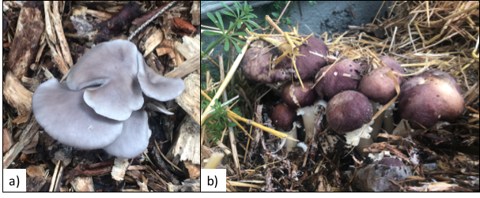
Figure 9.1. Woodchips/straw mulches can be inoculated with various fungi to help break down organic materials. Basidiomycete fungi such as Pleurotus ostreatus, the oyster mushroom (a), Stropharia rugoso-annulata, the garden giant (b), produce edible fruiting bodies in cultivated mulched beds as a secondary product while improving nutrient cycling in the soil.

Fungal saprobes act as primary decomposers, being the first one on the site to begin breaking the material down. The hyphal structure of fungi is advantageous for gaining first access to the interior of solid substrates; rather than solely eat from the margins of solid food sources, fungi may invade solid interiors to eat them inside-out.
Fungi are highly adapted to break down difficult to decompose, recalcitrant materials, including cellulose, lignin, chitin, keratin and the wax and protein coatings surrounding pollen. In addition to their ability to internally colonize solid substrates such as wood, many fungal saprophytes even colonize substrates while the host organism is still alive as endophytes. In this way they are possibly acting as latent decomposers, granting them first access to this food resource (Parfitt et al. 2010).
Later, secondary and tertiary decomposers (bacteria, actinomycetes, and other fungi) can come in and further breakdown these materials. Often these “secondary” decomposers take advantage of the passageways created by the primary fungal colonizer by traveling along the hyphal surface or within the hyphae as endosymbionts.
Often when fungi colonize and begin to decompose straw or mulch on the top layer of soil, this draws secondary decomposers, followed by organisms of increasing trophic levels, further increasing soil biology and complexity. This speeds up and improves nutrient cycling, thereby increasing the amount of nutrients available to the plants. Increasing the complexity and diversity of the biology in an agricultural system may help make the soil community more resilient and resistant to runaway pathogen populations.
Certain saprophytes can be used to control soil borne pathogens. There is significant competition for the dead material that serves as food for saprophytes and scavengers. Many saprophytic fungi are adept at competing for food and space in the soil against plant pathogens (many of which can exist as facultative saprophytes in soil as well). Therefore, a robust community of saprophytes, whether they are specific antagonists of a particular pathogen or not, can reduce the pathogen population. Some soil fungi may even produce antibiotic compounds specifically active against pathogens. Additionally, some soil organisms, including the aforementioned Trichoderma sp., are also capable of parasitizing soil-borne, plant-pathogens directly.
As members of the soil food web, fungi are typically consumed by earthworms, microarthropods, insects, and even small mammals and birds. As these predators consume the nutrient dense fungi, they excrete waste which can be rich in plant available nutrients. In general, fungi have a carbon:nitrogen that can be as low as 3:1 to as high as 220:1 (Zhang and Elser 2017). The lower ratios are more commonly found in younger mycelium and hyphal tips whereas larger c:n ratios likely indicate older hyphae. Therefore, as predators consume fungal structures they release valuable plant-available nutrients.
Fungi that are primary saprophytes are typically classified as either brown rot or white rot fungi. The former decompose cellulose, leaving lignin (brown) behind whereas the latter digest lignin, leaving cellulose (white) behind (Fig. 2). Because of this, anywhere where there are dead or dying plants, there will be fungi there working on digesting this material and returning the nutrients back into the soil.
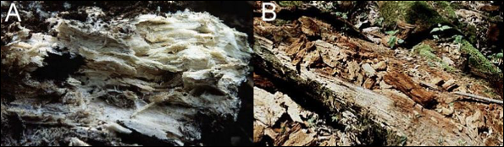
Figure 9.2. White rot fungi (A) that degrade lignin leaving the white cellulose behind vs. brown rot fungi (B) consume the cellulose and are unable to digest the brown lignin.

As fungi and other soil biology biodegrade large organic materials, this contributes to the humus layer of the soil. A diverse soil microbiota will develop humus more quickly in soils than low diversity soils (Dick and Gregorich 2004). The higher the humus or organic matter levels in the soil, the greater its cation exchange capacity (CEC) will be.
The CEC is a metric that is used to measure the quantity of mineral nutrients that a soil can hold on to; increased CEC levels have the ability to retain more nutrients elements and later make available to the plants. The cation exchange capacity is defined by the amount of cations that can be held by the negative exchange sites found on soil particles or organic matter. The humus layer of soil can improve water retention, provide a buffer for temperature control and offer a number of other benefits to soil.
Humus is typically the black, crumbly soil aggregate that is made from soil life breaking down dead organic material to a point where it can not be further degraded. This leaves a material that is rich in polysaccharides and humic acids, full of positive and negative exchange sites for ions (positive and negative) to bind to, dramatically increasing the CEC of the soil matrix. The humus layer is found on the top most layer of soils, just above the topsoil. This layer provides an excellent habitat for soil organisms to thrive.
Use of synthetic, chemical nutrients typically reduces a soils’ organic matter and humus layers. Applications of chemical fertilizers bypass the need for plants to recruit soil-building mycorrhizae, and may result in lowered populations of beneficial fungi antagonistic to plant disease organisms (Bulluck et al. 2002). Populations of soil organisms will also be affected by changes in the osmotic potential of the soil solution in ways that can be adventitious to disease causing organisms (Ruser et al. 2006), like Pythium species. This can have long term impacts on soil, including compaction and erosion, but also has more immediate consequences such as plants that are more susceptible to abiotic and biotic stressors and an increasing need for pesticides (Abawi and Widmer, 2000).
Other management decisions can also negatively impact soil microbes. For instance, van Groenigen et al. 2010 found that fields with reduced tillage (opposed to conventional tillage methods) increased soil microbial biomass (van Groenigen et al. 2010). Therefore, the less destructive we can be on soil, the more biology can thrive and continue to grow.
By treating our soil with awareness of the life they contain and incorporating carbon-based nutrients and plant residues back into our soils, regenerative farmers are helping to maintain and stimulate our microbial populations, thereby lessening our need for fungicides and herbicides and heavy salt fertilizers (Higa and Parr, 1994). This makes farmers less reliant on these large companies producing perto-based chemicals and the pesticides to go along with them. Big agriculture is following a system that makes the farmer more and more reliant on these large companies, allowing them less and less margins for saving while at the same time destroying the soils that are so important for the future of life on this planet.
Another way that biological farmers are beginning to increase soil CEC and organic matter levels is by applying compost to fields prior to planting. Compost is full of nutrients from the decomposition of whatever sort of organic materials were added to the compost pile. Compost made of manure from different animals will typically also have different nutrient profiles and microbial communities. In addition to the nutrients compost will add to your fields, it also serves to inoculate the soil with new microbes. It is important to create or source properly produced compost in order to ensure beneficial microbes are being added, rather than potential pathogens.
Compost can be spread across fields after it has been curing for the appropriate amount of time, or it can be brewed into a tea and either foliar fed to your plants or made into a compost extract and applied to your plants via root drench. The end goal with these techniques is to inoculate the plants and soil with bioavailable nutrients, novel biocompounds produced from the decomposition of organic materials, and a diversity of microbiology.
The biology and community dynamics found with-in compost can be extremely complex and variable. Since compost, like soil, is not a homogenous environment but instead is an elaborate matrix comprising many microclimates and niches for many different organisms to fill. This is further complicated by the fact that the community can change over time as different nutrients become available and as the environment changes.

Variables such as temperature, moisture, and input materials all influence the composting process and can determine or select which organisms are present. When a compost pile is first formed, the raw ingredients are mixed up and the microbes begin to go to work. Some of these microorganisms were already on the raw materials at the time of building the compost pile, whereas others were floating in the air and happened to land on the pile during composting the process.
After a few days (depending on a number of variables such as outside temperature/humidity, size of pile, shape of pile, input materials used, moisture of the feed stocks, etc.), the piles will begin to heat up. This is the result of microbes releasing heat as a by-product of their metabolism and exothermic chemical reactions that break down organic materials. The key components of a compost pile are simply organic material, air, water, and living organisms.

The beneficial organisms that will survive through composting and are desired as soil inoculants require air (for the most part), water, and a food source. Therefore, it is important to keep composts (and soils) moist to ensure that the biology can remain active. As compost piles are turned this introduces fresh air, rich in oxygen, and the pile cools down in the short term. After a few hours the pile will begin to heat up again as newly available oxygen stimulates increased microbial growth.
The National Organic Program (NOP) states that a thermophilic compost pile must be mixed and processed so that the pile reaches a temperature of at least 131oF for a minimum of three days (§ 205.203(c)). A compost pile that fails to heat to these temperature standards indicates a lack of sufficient biological activity. This could result from not enough or too much moisture, a lack of oxygen within the pile, an improper ratio of materials, or a combination of these factors. Reaching proper temperatures for the specified amount of time ensures the pile destroys many plant pathogenic species, as well as noxious weed seeds.
Temperature is one of the primary selectors of microbial communities in compost; filamentous fungi are most active and competitive at cooler temperatures (77oF-86oF), whereas bacteria and yeast dominate at higher temps. As a compost begins to finish, temperatures will begin to cool and eventually reach near ambient temps. This is a sign that most of the organic matter has been digested to a point where it is relatively stable. At this point, compost can be used by farmers, not only as a source of nutrients for their soil and plants, but also an inoculant rich in beneficial bacteria, fungi, protists, nematodes and many other organisms.
A well produced compost should improve plant health and may even induce disease suppressive soil, whereas a poorly produced compost can act in exactly the opposite manner by introducing or spreading pathogens and weeds into your planting area.

Chapter 10
Entomopathogenic and Predacious Fungi

This chapter describes how some fungi act as parasites on host organisms and consume living invertebrates such as arthropods, insects, nematodes, or rotifers (e.g. Arthrobotrys oligospora). These fungi have developed specialized mechanisms for attracting and consuming these organisms and therefore play an important role in determining the soil ecology. Some of the parasitic fungi can even consume other fungi, acting as mycoparasites. When such fungi’s hosts are themselves parasites, they are known as hyperparasites (Ampelomyces quisqualis is an example of a fungal hyperparasite among members of the powdery mildews in the order Erysiphales). There are a growing number of biocontrol products available to Cannabis cultivators that contain entomopathogenic fungi that can be used to decrease pest pressure and may have other mechanisms for facilitating increased plant growth as well (Table 1).
Table 1. Commercially available biocontrol fungi that can act as bioinsecticides include Beauvaria bassiana, Metarhizium anisopliae, and Isaria fumosorosea.
Fungus | Product
Beauvaria bassiana | Mycotrol, Botanigard, Bioceres
Metarhizium anisopliae | Met 52, Met Master
Isaria fumosorosea | PFR-97, Ancora

Fungi can act as parasites or pathogens on pretty much every other form of eukaryotic life. One group of soil-borne and endophytic fungi, known as entomopathogenic fungi, will germinate spores when they come in contact with the proper insect body under favorable conditions. The hyphae will grow into the body of the insect, slowly digesting the insect's organs. Some entomopathogenic fungi are even able to hijack their host animal’s consciousness, forcing them to crawl to a the highest point available, so that the fungus can produce a spore bearing structure and disperse its spores to a larger range (e.g. Beauveria bassiana) .

Perhaps the most famous example of this is the fungus Opihocordyceps sinensis which infects the larval stage of ghost moths in the Himalayas (Fig. 1). Once the caterpillar is inoculated and fully colonized, the fungus produces a mushroom that sprouts directly out of the mummified corpse. This fungus is particularly notable for its use in Chinese medicine and is being researched in the US for its cytotoxic properties that may prove useful in the treatment of cancers (Yoshida et al 1989).
A commercially available entomopathogenic fungi that has utility to Cannabis farmers is the fungus Beauveria bassiana, the active ingredient in the products Mycotrol and Botanigard. This entomopathogenic fungus is able to live endophytically within a diversity of plant species, probably Cannabis among them. In this way it may act as a bioinsecticide, while at the same time controlling plant pathogens and promoting improved plant growth. This is a rather commonly encountered fungus found in soils, peat bogs, waterways, and birds nests throughout the world (Zimmerman 2007). Zimmerman also reports that B. bassiana has over 100 different insect hosts that it can infect. A related entomopathogenic fungus, Purpureocillium lilacinum, has been found as a common species occurring on California dispensary Cannabis (Thompson et al 2016). Both of these fungi are within the order Hypocreales, a clade characterized by members with parasitic lifestyles on insects, arthropods, plants, and even other fungi. The common edible fungi, the “lobster mushroom,” is actually a species of Russula or Lactifluus parasitized by Hypomyces lactifluorum.

Most entomopathogenic fungi that infect insects percutaneously (through cuticle) do so in four major steps: 1) Attachment of a spore or conidium to the insect body. 2) Spore germination. 3) Penetration through cuticle. 4) Outperforming host immune system. 5) Invasion of the host body by growing hyphae or producing conidia/spores. 6) Production of sporulating structure outside of mummified insect body (Zimmerman 2007).
Once the spore becomes attached to the insect cuticle, environmental and host cues initiate spore germination. As the germ tube forms into hyphae the fungus searches for weaker areas of the insect, such as joints or sockets. When a susceptible location is reached, the fungus forms an appressorium and penetration peg. Exoenzymes are released from the penetration peg to weaken the cell wall. These mechanisms allow for the physical penetration of the host body. Once inside the fungus must evade the host immune system. In response, the host mounts a defense by producing antifungal compounds, but the fungus can form hyphal bodies (which are superficially similar to yeast cells) able to spread throughout the host circulatory system. Once the insect is fully colonized and mummified by fungal hyphae, reproductive structures develop outside of the host's body in order to disperse to new fresh food resources in the form of new insect and arthropod victims (Zimmerman 2007).

Nematophagous fungi
There are also a number of fungi that can consume nematodes as a source of nutrients. Nematodes are ubiquitous in soil, water and in other decaying organic matter. In environments where nutrients are limiting, especially nitrogen (such as inside a downed log), there is intense competition amongst the inhabitants for their procurement. As a result, some fungi, referred to as nematophagous fungi, have evolved novel mechanisms for consuming nitrogen rich nematodes (Fig. 3). Nematodes provide a source of concentrated nitrogen and other nutrients, which the fungi may then directly absorb. This adaptation has evolved multiple times across different fungal lineages, an example of convergent evolutions.
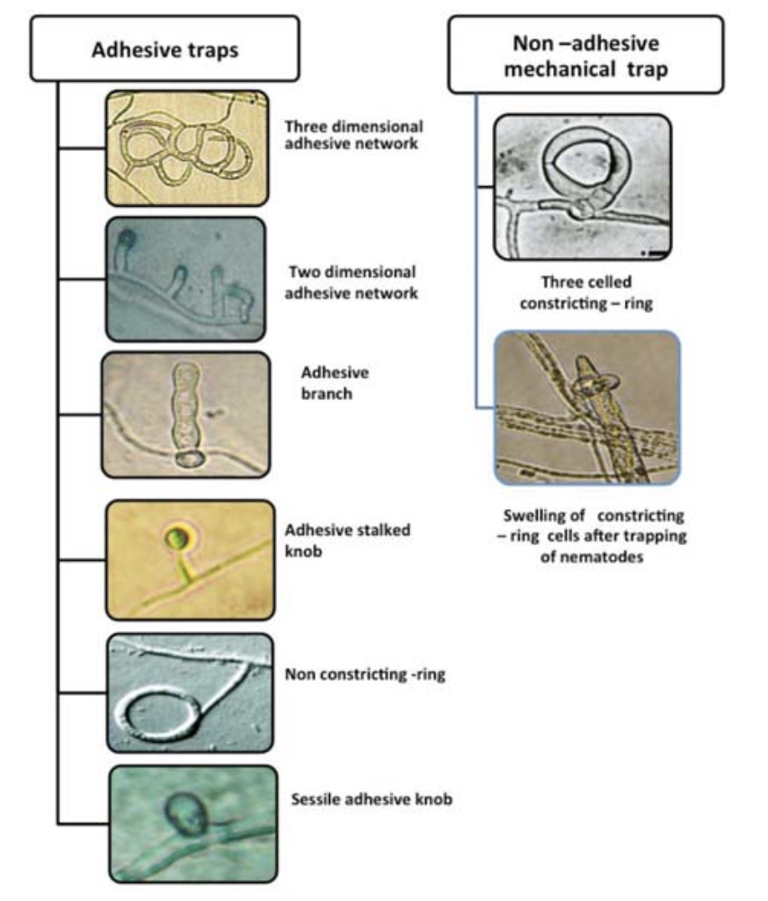
Figure 10.1 Examples of different types of traps that various fungi employ to lure and capture nematodes in soil. (Kumar 2017).

Nematophagous fungi are paraphyletic, meaning they are found in different phyla throughout the fungal kingdom representing different evolutionary origins. Many are imperfect soil fungi whose sexual state has not been observed, while others are grouped within the chytrids, ‘Zygomycetes,’ and even mushroom-producing Basidiomycetes -including members of the well known edible genera, Pleurotus (Marlin et al. 2019).
These carnivorous fungi have evolved different methods for acquiring nutrients from mobile nematodes. Some fungi produce conidia that are consumed by nematodes and, once inside, the fungal parasite germinates and consumes the animal from the inside out. Others produce physical structure in their hyphae such as hyphal loops that constrict on the wiggling nematode or a sticky peg that produces pheromones to attract the worm. Still others create a sort of mycelial net that can trap nematodes.
Gorfer et al. concluded that agricultural practices that increase soil carbon typically have increased fungal biomass, which leads to less nitrogen being lost from the system. Conversely, soils with little fungal biomass are more prone to leaching nitrogen off the farm (Gorfer et al. 2022). When fungi assimilate nitrogen and other nutrients and store it in their cells in the form of proteins or carbohydrates or other organic molecules, they become a prime food source for members of higher trophic levels in the soil food web. Fungal predators include nematodes, microarthropods, worms, birds, mammals and others.
As predators consume fungi, they excrete waste which can be in the form of plant available nutrients, thus propelling the nitrogen cycle and allowing other organisms to compete for them. Despite this propensity towards increasing nitrogen retention in soil, fungi may play complex and paradoxical roles in the cycling of nitrogen in soil systems. Fungi are able to transform various nitrogen containing molecules, contributing to all aspects in the nitrogen cycle, including the denitrification process. Certain soil fungi can metabolize nitrate and release nitrous gas in low oxygen environments (Hayatsu et al. 2008).

In summary:
- Some fungi have evolved to consume insects or other fungi
- Entomopathogenic fungi can be used as biocontrol to protect plants from insect pests

Chapter 11
Fungi as Vectors:
Fungi Can Vector Plant Viruses, Viroids, and Bacteria

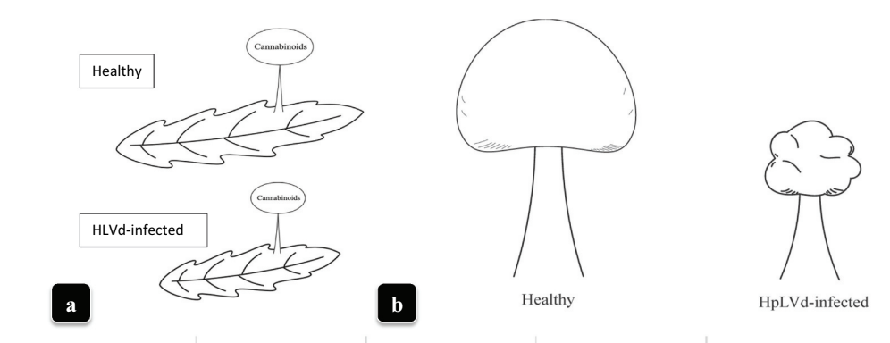
Figure 1. Effect of virus on Cannabis leaves (A) and trichomes (B). (Punja et al 2023)

Cannabis plants can serve as hosts to a variety of microorganisms, including fungi and bacteria. Additionally, these microbial symbionts (or pathogens) can themselves be infected by even smaller organisms, such as viruses and viroids. This chapter will explore how fungi can influence plant growth and performance, depending on whether the fungus is infected with other organisms. Research has indicated that certain fungi can act as vectors, facilitating the spread of viruses from one plant to another.
Viruses and viroids pose an emerging threat to farmers cultivating various crops. While many viruses exist without causing obvious harm to the host plant or may even be beneficial, their effects can sometimes lead to devastating diseases in plants. Viruses consist of DNA or RNA enclosed in a protein coat, whereas viroids are even smaller, containing low-molecular weight RNA without the protein coat (Fig 1). Both viruses and viroids rely on the cellular machinery of their host plants in order to replicate.
Table 11.1. Known viral, viroid, and phytoplasma diseases putatively affecting Cannabis. Phytoplasma diseases are obligate bacterial parasites of plants vectored by insects or arthropods.

Viruses | Viroid | Phytoplasma
- Beet curly top virus (BCTV)  - Alfalfa mosaic virus (AMV)  - Arabis mosaic virus (ArMV)  - Cucumber mosaic virus (CMV)  - Tobacco ringspot virus (TRSV)  - Tomato ringspot virus (ToRSV)  - Tobacco streak virus (TSV)  - Tomato mosaic virus (ToMV) | - Hop Latent Viroid (HLVd) | - Candidatus phytoplasma trifolii

Fungi naturally acquire viruses and viroids in a manner similar to plants. Many plant and fungal viruses do not persist outside of their hosts for long, even with protective capsids. Unencapsulated RNA and DNA are typically quickly degraded or destroyed in the external environment. However, viroids, in particular, have shown an impressive ability to persist without a protective protein capsule. They can survive for days on surfaces, weeks in water, years in dried plant material, and even decades within seeds (Singh et al., 1977; Singh et al., 1991; Mackie et al., 2015). The unique tertiary structure formed by viroid RNA, which loops back upon itself, is likely responsible for its remarkable resilience to degradation and plays a role in its interactions with host proteins (Hull, 2014).
Even when infectious viroids and viruses are present in the environment, plants have protective structures that usually exclude them. In order to enter an uninjured plant, viruses and viroids may first infect an organism, such as a fungus, which can then serve as a vector to transfer the infectious agent to the plant. Fungi acquire nutrients by engulfing material through endocytosis (Barata-Antunes et al., 2021). This engulfed material may include infectious agents, which are able to evade digestion.
Fungi were first confirmed to become infected with plant viroids—where active viroid replication occurs—when avocado sunblotch viroid was shown to infect and replicate in Saccharomyces cerevisiae (baker's yeast) (Delan-Forino et al., 2011). More recently, it has been demonstrated that various plant-interacting fungi are capable of hosting plant viroids (Friday et al., 2017; Wei et al., 2019).
Andika et al. experimentally confirmed that fungi can act as vectors for plant pathogenic viruses, transferring these viruses into previously uninfected plants (Andika et al., 2017). A notable model system for this interaction involves the cucumber mosaic virus (CMV), Rhizoctonia solani, and Solanum lycopersicum (tomatoes). This is an especially relevant system as both CMV and R. solani are plant pathogens with broad host ranges (including cannabis), making them significant for most farmers and gardeners. Rhizoctonia solani is known for causing damping off and root rots.
There is no reason to believe that only pathogenic fungi can transmit viruses in this way. Although the documented cases thus far have involved experimentally infected fungi, and natural viroid infections of fungi have not yet been identified, it is increasingly accepted that such infections likely occur in nature (Sun and Hadidi, 2022). The likelihood of a virus or viroid being vectored into a plant by a fungus depends not only on the host-virus/viroid interaction but also on the microbiome and environmental context in which the interaction occurs. For example, Bain et al. showed that Cryphonectria hypovirus 1 (CHV1) could infect a plant leaf but could not move systemically through the plant unless the host was co-infected with tobacco mosaic virus (TMV). The viroid relied on TMV movement proteins to move from cell to cell. Interestingly, this same group demonstrated that the plant-pathogenic fungus Fusarium graminearum was more susceptible to TMV infection when co-infected with CHV1 due to CHV1's disruption of the fungal host’s RNA-silencing-based immune responses.
It is likely that plant mutualistic fungi are also capable of hosting and transmitting harmful plant viruses in a similar manner to pathogenic fungi. Additionally, bacteria and archaea may internalize and transfer plant and fungal viruses/viroids within the environment to new hosts. Bacteria and archaea have cellular machinery that allows them to internalize exogenous DNA, which can become an important source of genetic novelty if incorporated into their genome (Wagner et al., 2017).
Fungi can also transfer viruses among each other through anastomosis (hyphal fusion) of compatible fungi. When hyphae fuse, they are able to transfer cytoplasm and much of its contents, including viruses, between the fungi. In the case of ascomycetes, even nuclei can flow freely between the fungi. If the fungi are compatible, they will transfer viruses contained in the cytoplasm into the newly fused individual. Sometimes, non-compatible fungi may form transient bridges, posing a viral transfer risk even if anastomosis is not stable.
Fungi represent potential reservoirs of plant viruses. It is likely that both mutualistic and pathogenic fungi have complex relationships with viruses—ranging from harmful to beneficial—that can infect plants. This “harmful or helpful” relationship can vary depending on whether the virus is infecting the fungus or the plant, and under different environmental conditions.
For cultivators concerned with viruses, one approach to limiting the introduction of viruses is to select germplasm that has been screened for viruses and is known to be tolerant of infection. Additionally, tools—especially blades—should be sterilized between plants to limit the movement of viruses, thus preventing their spread on the farm (Miotti et al., 2023). It is also important to manage insect pests both indoors and outdoors, creating a competitive environment that reduces their impact and population, as insects are often vectors of viruses. This strategy should include recognizing that viruses, viroids, and even bacteria can survive and maintain themselves within alternative host organisms, including fungi, even in otherwise unfavorable environments. Beyond strong preventative hygiene practices, growers need not be overly concerned about viruses and viroids unless they are experiencing problems with these agents.
Table 11. 2 Tool sterilization solutions effective at eliminating most plant viroids. Concentration of sterilizing agent and contact time both affect sterilization efficacy (Kai-Shu Ling, 2017).
 | Time | Efficacy
10-20% household bleach | 5-10 minutes | Very effective but corrosive on tools
2% Virkon | Disinfect until visibly clean | Very effective
20% Dry Skim Milk | 10-20 minutes | Partially effective

When experiencing a viral problem, one option to consider is performing a 'farm reset,' which involves pasteurizing or sterilizing the soil or media. This process is aimed at removing a significant portion of the living fungi that could potentially host plant viruses. Afterward, amending the soil with known disease-free, living soil or compost can help inoculate it with pathogen-free soil microbes. A diverse microbial population in the soil will help limit the spread of viruses by spatially separating the range of potential host organisms, which may interact in a way that could lead to pathogen transfer—such as anastomosis of compatible vegetative fungal individuals.
The symptoms of viral infections in plants can vary widely, from severe symptoms to being completely asymptomatic. Because of this variability, it is crucial to have sophisticated identification tools available to detect infected plants. Techniques like ELISA (Enzyme-Linked Immunosorbent Assay), DNA/RNA hybridization, PCR (Polymerase Chain Reaction), and gel electrophoresis are commonly used to identify viruses and viroids in plants. These methods can provide highly sensitive and accurate results, allowing growers to detect even low levels of infection that might otherwise go unnoticed.

In summary:

- Viruses and viroids can pose a serious threat to Cannabis cultivators everywhere
- Fungi can act as vectors transmitting viruses or other diseases to plants

